De Nora Tech CISEP Work Instructions
Prepared by: MJM Automation
- Objective:
  - The objective of this document is to outline the operating procedure of De Nora Tech’s CISEP pH Monitoring software, with directions on how to start up new cells, take cells offline, adjust scan rate, etc.
- Runtime Menu:
  - Lab Info
    - In this section, you will find the lab info. This should have been set for you already, but if not, name the lab as you please, set the scan rate, and the excel file path. This is where files will save if you press the “Save Current Graph” button.
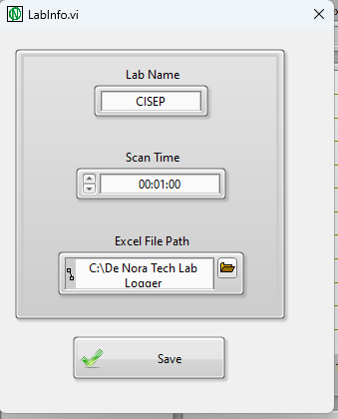
    - When you’re finished, press save, and then the X in the top right corner.
  - Calibrate Pumps
    - This will be used to calibrate any and all pumps you may have.
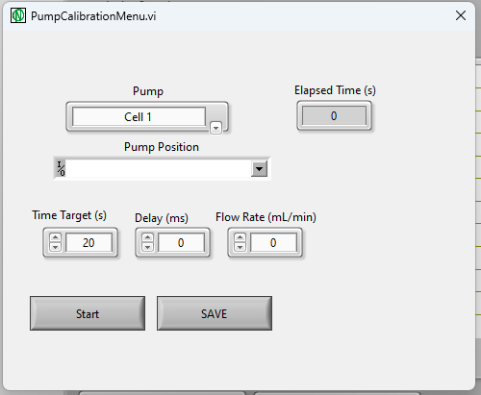
    - Pump
      - This is the pump file that will be overwritten. If you are going to be creating a new pump calibration entirely, browse to “C:\De Nora Tech Lab Logger\Pump Calibration Files” and delete the calibration for the existing cell that you want to recalibrate.
    - Pump Position
      - This is the actual location of the IO map.
      - For your cell, the position will be shown below. Note that this should have been done for you already, and you shouldn’t need recalibration for a few months at the earliest.
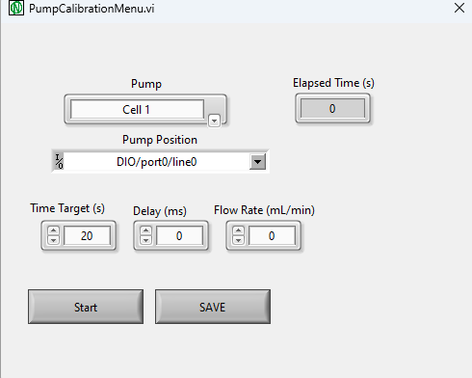
    - Time Target
      - This is the amount of time the pump will run for when you press the start button
    - Delay (ms)
      - This is the amount of time the pump will be on at a high rate. This is due to the nature of the stepper motor driving the pump. For a detailed explanation of how stepper motors are controlled, there are some great YouTube instructional videos.
    - Flow Rate
      - This is the flow rate at the given delay time. You will want to enter this information after the pump has stopped, and then press the save button to enter that data point into the calibration file.
  - DAQ Map
    - This also should be done for you, but if you need to make changes in the future, the IO point is where the pH probe is connected, and the Pump DIO is where the pump’s control is connected.
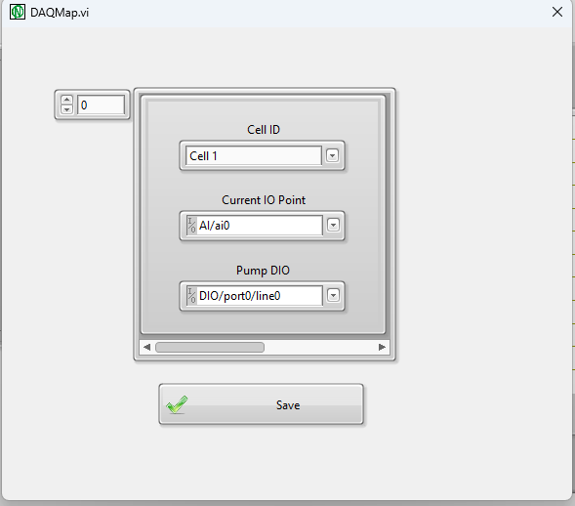
  - PID Tune
    - You will want to adjust this, if you are not reaching setpoint fast enough, or vice versa. To get to setpoint faster, increase Kc, or decrease Ti. You will not want one without the other, so this is a challenging game of balance. For more information on tuning PID loops, again, YouTube has some great tutorials.
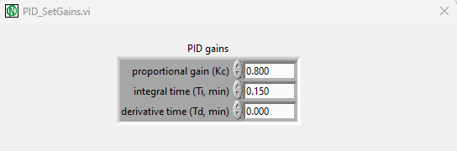
  - Create New Sample
    - Here is where you can create your samples. Be sure to set the Cell location (for this control box, only Cell 1 is used) give the sample a name, input the setpoint, and press save. Once done, press the X in the top right corner.
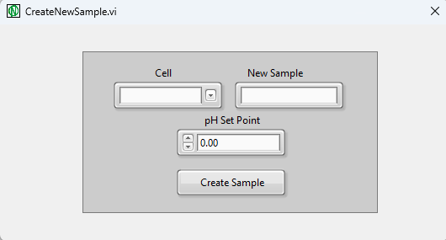
  - Search Active Cells
    - In this menu, you can see what cells currently have a sample active, and delete any samples you may be done with. This does not delete the data, it only removes it from the table view, and stops the pump it is connected to.
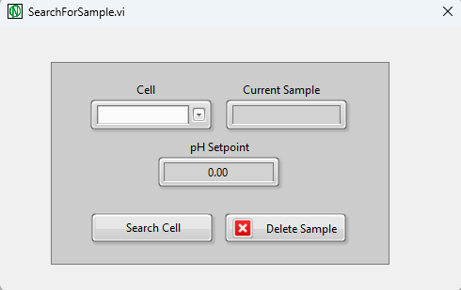
  - Exit
    - This closes the program.
- Main VI
  - Below is a screenshot of your main .VI
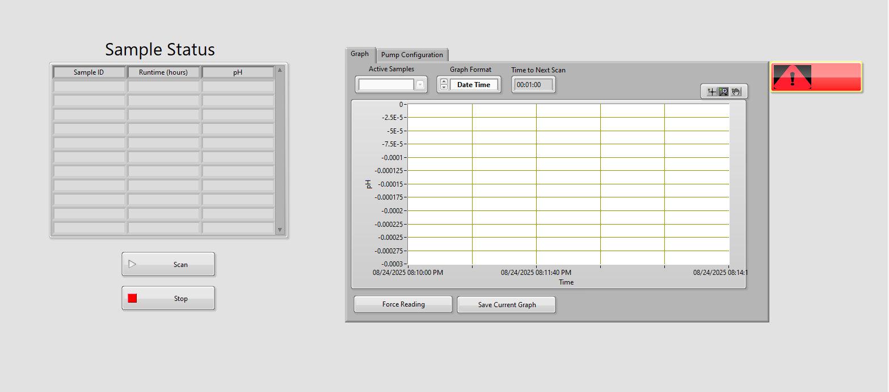
  - Now going through each item:
    - Sample Status Table
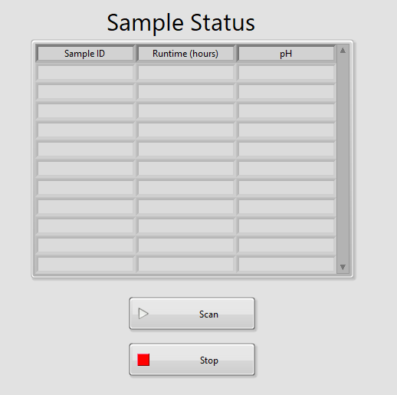
      - This is where any active cells will show up. To make sure data is being collected, make sure the scan button is pressed. To stop data collection, press the stop button. This however, will not stop the pumps from controlling the pH.
    - Graph View Tab
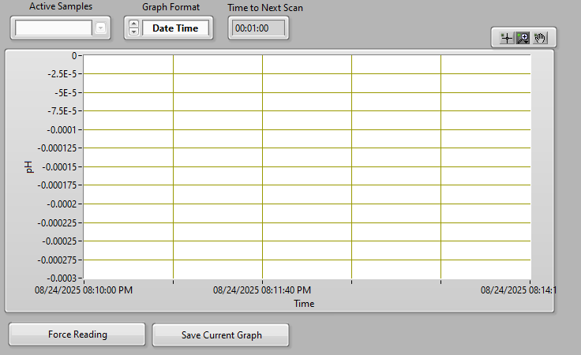
    - This is where you can view the data in real time. To force a reading, press the first button below the graph. To save the graph to an excel sheet, press the second button. This will save the file wherever you have it specified in Section 2.1.1.
    - Pump Configuration Tab
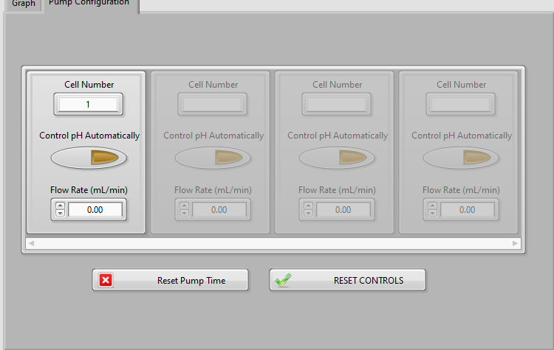
      - This is where you will find all the controls for your pumps. The pumps will automatically turn off after 5 hours, and let you know in the error monitor you will find later in this document. To combat this, press the “Reset Pump Time” button.
      - The “RESET CONTROLS” button is used to make changes to the pump configuration found above. As requested, if the pH is outside of operating range, the program will give you an error message, and switch to flow rate control.
      - To change the settings, first press the “RESET CONTROLS” button, it will illuminate orange. Then, simply press the “Control pH Automatically” button. When the reset button goes back to gray, make sure the pH button is now illuminated.
    - Error Monitor
      - This is where all errors that may occur will populate.
